DEVOPS

Maven:-

Compiled -Java

Interpreter -Phython

Complied is faster then Interpreted language

Maven is build tool which it is use for java projects

Process:-

GitCheckout🡪code build🡪codecheck

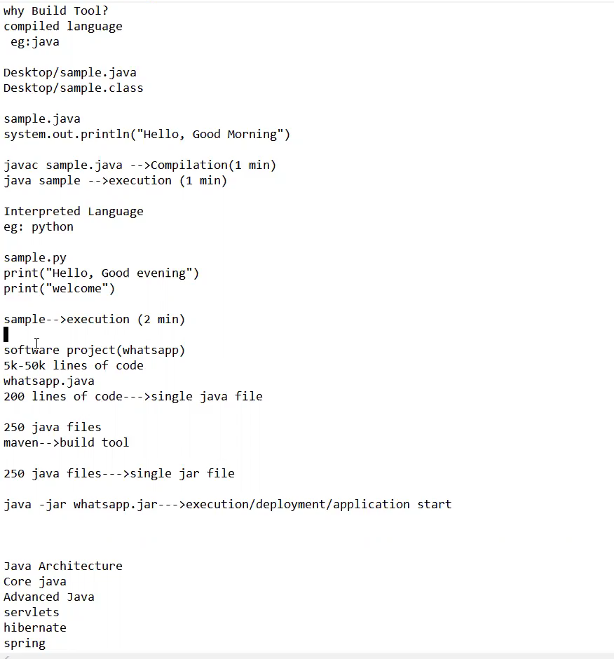

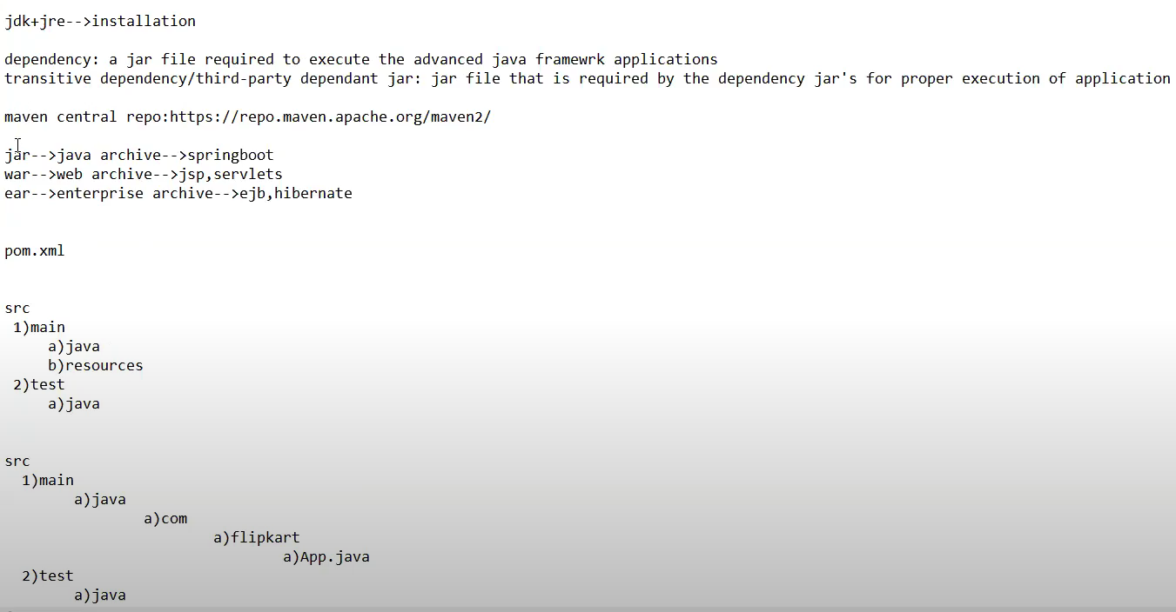

Maven knows which file to generate

Ex:if code Written in Springboot it will create jar file

Ex:If code written in CoreJava/jsp/servlets

Ex:If code written in EJb/hibernate

🡪under src/main

*)Application related java files

🡪under src/test

*)Testing related java files

MAVEN INSTALLING:-

1)Install new AWS instance with ubuntu1.8 free tier

2)Go to browser for OpenJdk by using below link

<https://openjdk.org/install/>

3)login to putty/mobaxterm

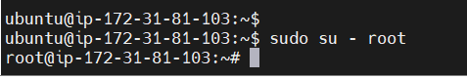

cd /opt

apt-get update

ex: 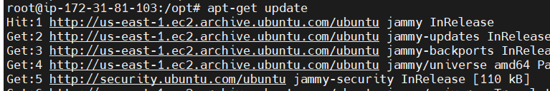

3)Install OpenJdk by using below commands

#apt-get install openjdk-8-jdk

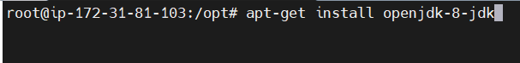

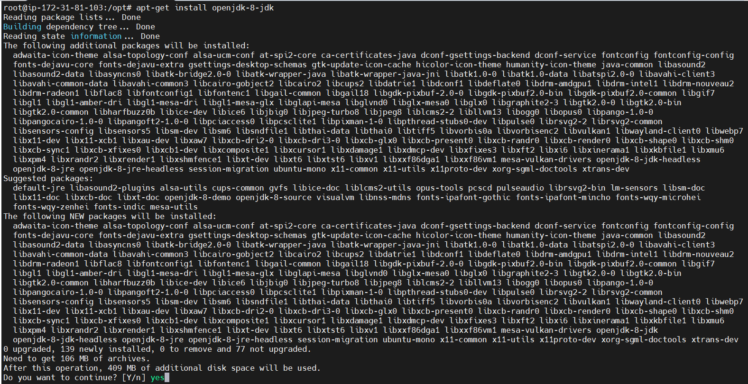

4)Check version

#java -version

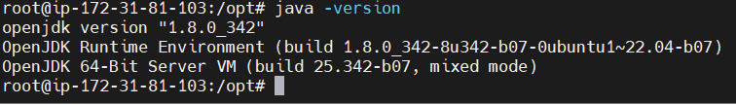

5)install maven in remote server by using below commands

go to browser and download maven by using below link

<https://maven.apache.org/download.cgi>

# wget <https://dlcdn.apache.org/maven/maven-3/3.8.6/binaries/apache-maven-3.8.6-bin.tar.gz>

Ex: 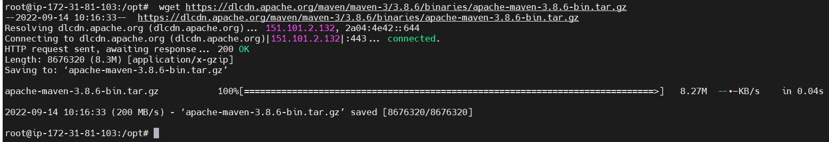

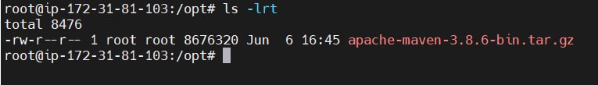

6)Extract the file by using below command

#tar -xzvf apache-maven-3.8.6-bin.tar.gz

Ex: 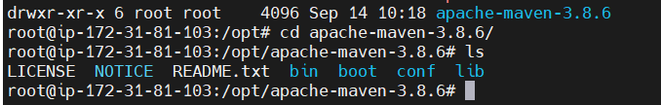

7)Set environment variable

#echo $PATH

#export PATH=$PATH:/opt/apache-maven-3.8.6/bin

ex: 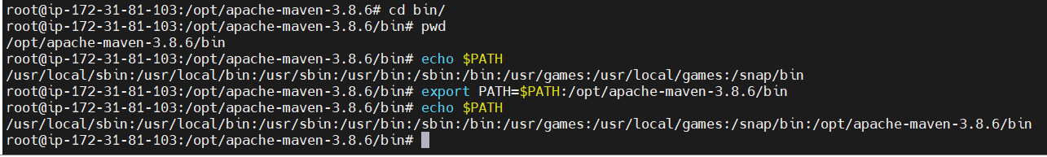

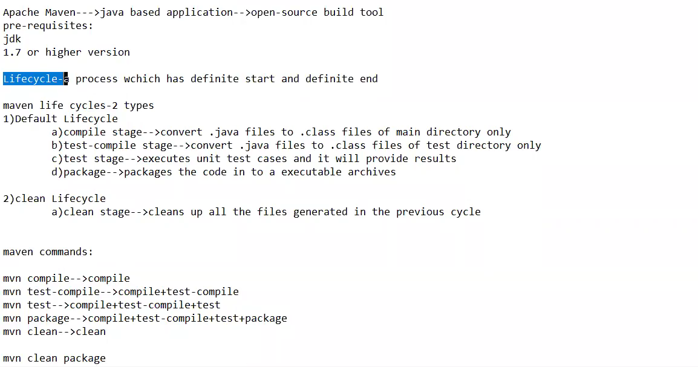

In realtime env using below command:-

mvn package [complile+test-compile+test+package]

mvn clean -Dmaven.test.skip=true

Real time scenarios:-

Ex: git clone [https://github.com/shoil/maven-sample-code.git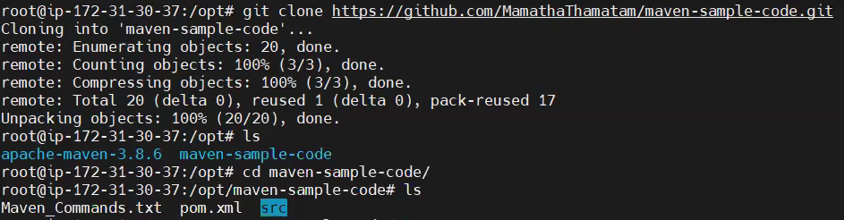](https://github.com/shoil/maven-sample-code.git#)

#apt-get install -y tree

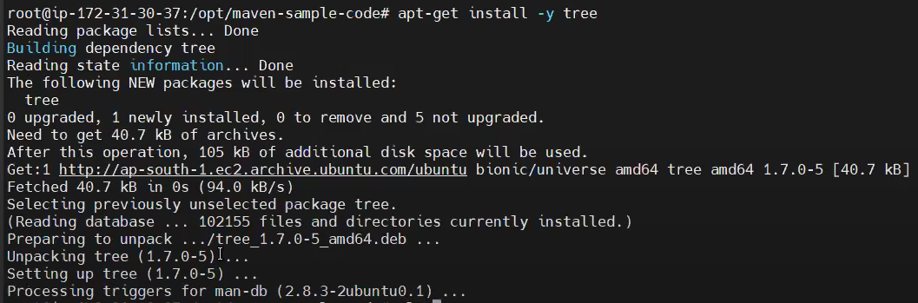

#tree

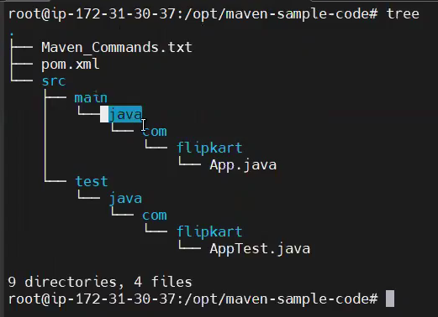

🡪Now we can compile the code by excuting below command

cd /opt/maven-sample-code/

mvn compile [it will download all the libraries from central repo]

ex: 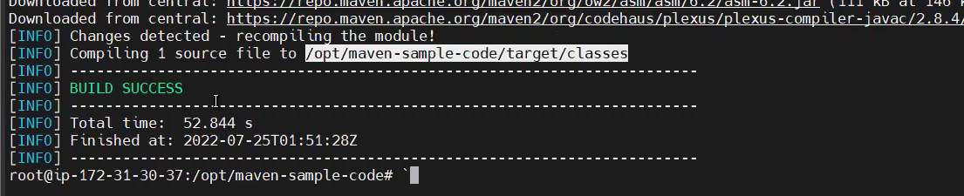

Then it will create Target directory and this will compile for only Main directory

Ex

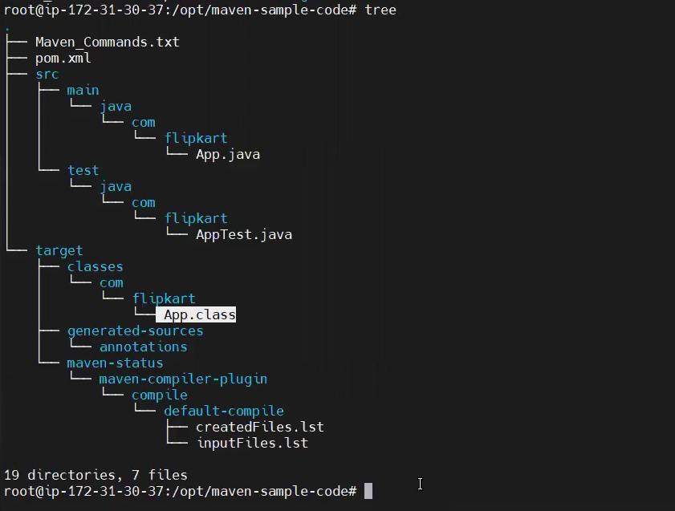

🡪Now this will also download some required libraries

#**mvn test** [it will convert .java to .class in test dir]

Ex:

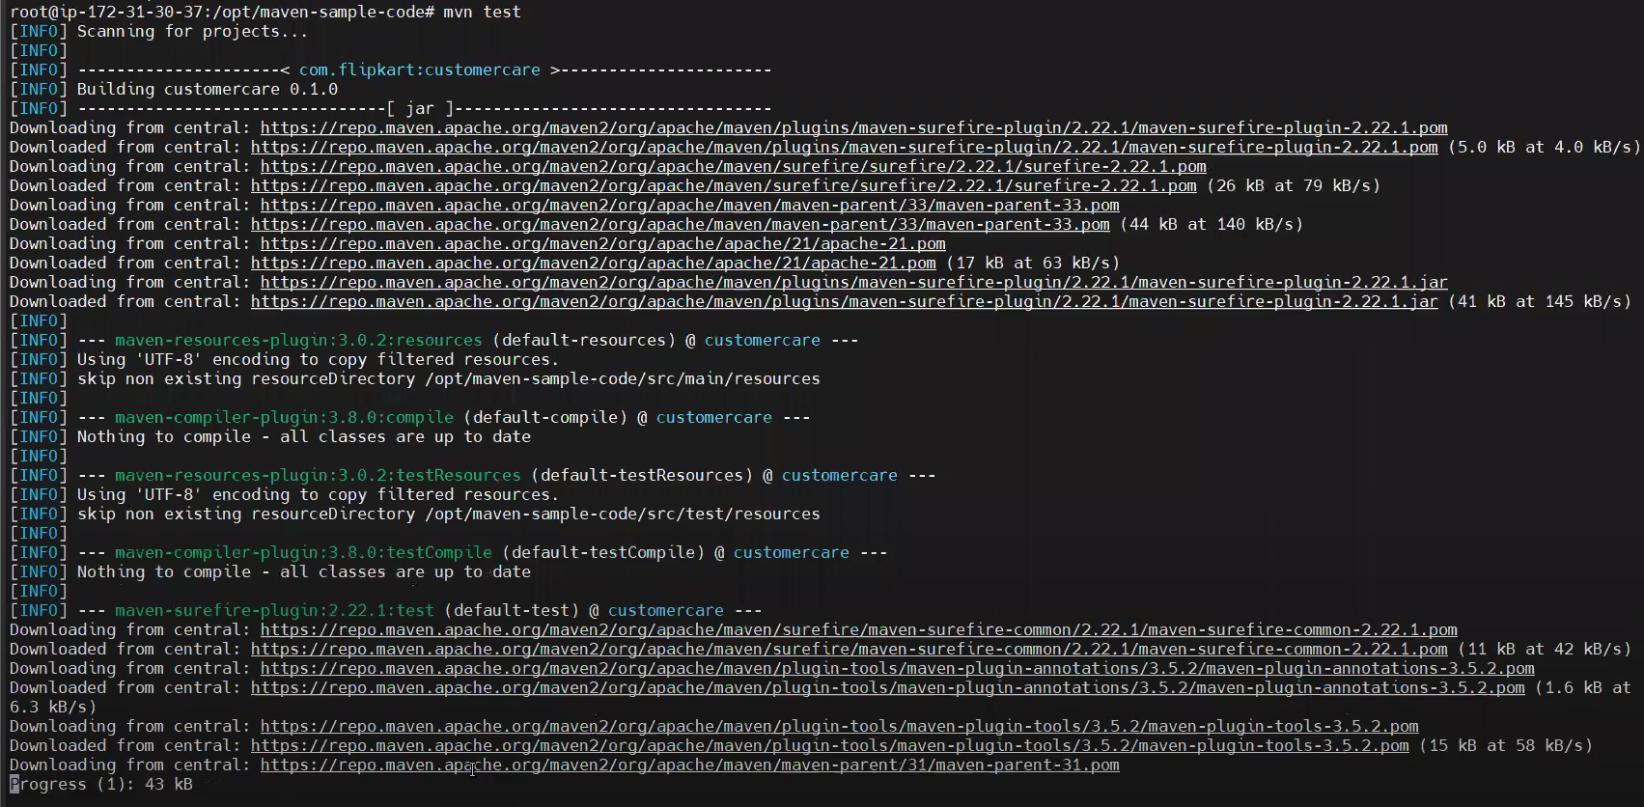

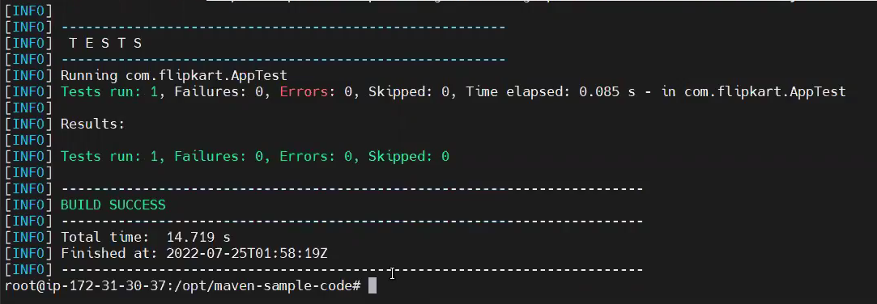

🡪Now will tree complete compile by using

#mvn package [it will create jar file under /target dir

Ex: 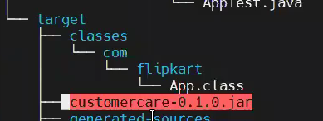

🡪Now try to clean by using below commands

#mvn clean [it will clear up all files which are generated in previous build]

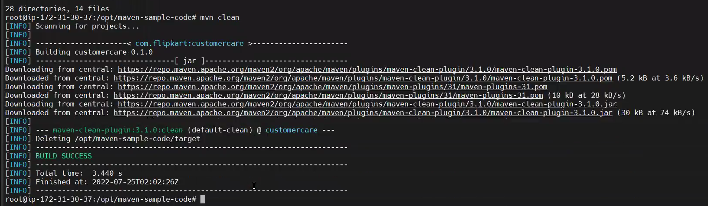

🡪If you want to do both in single or at a time by using below command

#mvn clean package [It will clen up all previous file and install .jar file under /target]

Ex:

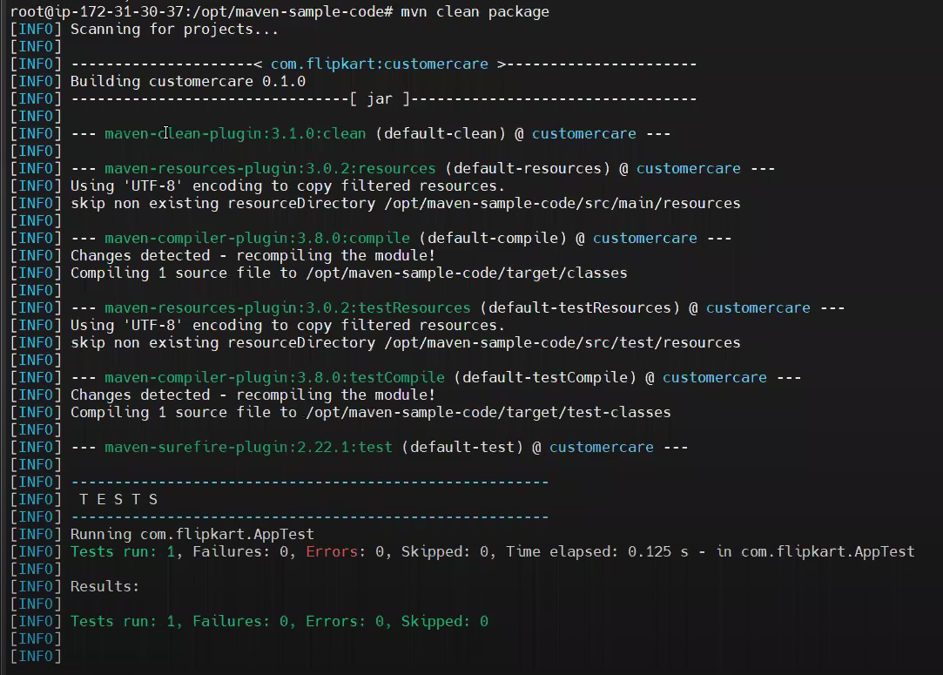

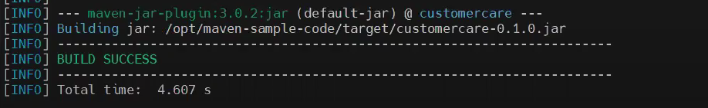

🡪#mvn clean package -Dmaven.test.skip=true

Ex: 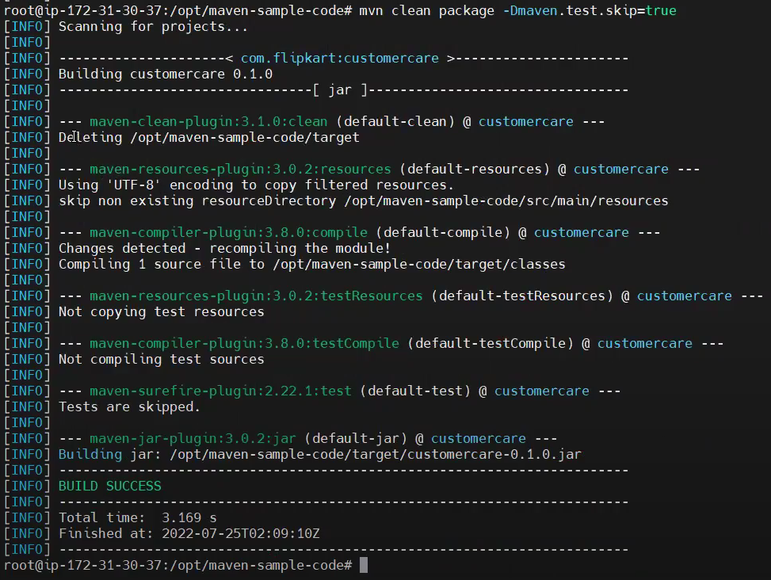

Command to deploy any jar file

#java -jar filenameof_jar

==================================================================================